

ETHICAL ISSUES IN COMPUTER AS AN INSTRUMENT FOR

TECHNOLOGICAL GROWTH

BY

**ZAKARI GHAZALI MUHAMMAD**

**NAS/CSC/20/1154**

A PROJECT SUBMITTED TO THE DEPARTMENT OF COMPUTER SCIENCE AND INFORMATION TECHNOLOGY, COLLEGE OF COMPUTING AND INFORMATION SCIENCE, ALQALAM UNIVERSITY KATSINA

IN PARTIAL FULFILMENT OF THE REQUIREMENT FOR THE AWARD OF BACHELORS DEGREE IN COMPUTER SCIENCE

AUGUST, 2024

# DECLARATION

I hereby declare that the work presented in the project entitled “**ETHICAL ISSUES IN COMPUTER AS AN INSTRUMENT FOR TECHNOLOGICAL GROWTH**” is an authentic record of my work and any other person referred to has been properly cited and not plagiarized. This BSc. Work is my original work and has not been presented for a degree award in this or any other university.

_______________________

Name of Author

_______________________

Date

# CERTIFICATION

This project titled “**ETHICAL ISSUES IN COMPUTER AS AN INSTRUMENT FOR TECHNOLOGICAL GROWTH**” By **ZAKARI GHAZALI MUHAMMAD** with registration number **NAS/CSC/20/1154** meets the requirements governing the award of the degree of Bachelor of Science in Computer Science and is approved for its contribution to knowledge and literary presentation.

________________________ ____________________

Mal Abdulmalik Umar Date

(Project Supervisor)

________________________ ____________________

Mal Abdulmalik Umar Date

(Project Coordinator)

________________________ ____________________

Dr. Sunusi Abu-Darma Date

(Head of Department)

# DEDICATION

This project is dedicated to Almighty Allah for His favors, mercy, and grace upon my life, especially during the period of my study. I also dedicate this work to my beloved family, whose unwavering support, encouragement, and prayers have been my source of strength and motivation. Their belief in my potential has driven me to achieve this milestone. Finally, I dedicate this work to all my mentors and friends who have provided guidance and support throughout this journey. Thank you all for your love and encouragement.

# ACKNOWLEDGEMENT

I am deeply grateful to everyone who has contributed to the successful completion of this research project. First and foremost, I would like to express my sincere appreciation to my supervisor, Malam Abdulmalik Umar for his invaluable guidance, insightful feedback, and unwavering support throughout this study. His expertise and encouragement have been instrumental in shaping the direction and quality of this research.

I would also like to extend my heartfelt thanks to the respondents who participated in this study, particularly the computer professionals, educators, students, and members of the general public. Their willingness to share their experiences and insights has provided the essential data for this research.

My gratitude goes to my colleagues and friends for their moral support and for providing a stimulating environment that has motivated me to persevere. Special thanks to my family for their love, patience, and constant encouragement, without which this project would not have been possible.

Lastly, I would like to acknowledge the institutions and organizations that facilitated this research by providing access to necessary resources and information. Your contributions have been invaluable, and I am deeply appreciative of your support. Thank you all for making this journey a rewarding and fulfilling experience.

# TABLE OF CONTENTS

DECLARATION i

CERTIFICATION ii

DEDICATION iii

ACKNOWLEDGEMENT iv

TABLE OF CONTENTS v

LIST OF TABLES vii

LIST OF FIGURES viii

LIST OF ABBREVIATIONS ix

ABSTRACT x

CHAPTER ONE 1

1.0 Introduction 1

1.1 Background of Study 1

1.2 Problem Statement 2

13 Research Question 3

1.4 Aim and Objectives 3

1.5 Significance of the Study 3

1.6 Scope of the Study 4

1.7 Chapter Summary 4

1.8 Operational Definition of Terms 5

CHAPTER TWO 6

2.0 Introduction 6

2.1 Reviewed Related Work 6

2.2 Conceptual Framework 9

2.2.1 Overview of Ethics 9

2.2.2 Significant Historical Advancement of Computer Ethics 12

2.2.3 Fundamental Aspects of Computing Ethics 13

2.2.4 Impact of Computing Ethics 15

2.3 Chapter Summary 16

CHAPTER THREE 17

3.0 Introduction 17

3.1 Research Design 17

3.2 Methods of Achieving Research Design 17

3.2.1 Sample and Sampling Techniques 17

3.2.2 Data Collection Instrument 18

3.2.3 Validity of the Instrument 18

3.2.4 Reliability of the Instrument 19

3.2.5 Data collection Procedure 19

3.2.5 Data Analysis 19

3.2.6 Ethics of the Study 21

3.3 Chapter Summary 21

CHAPTER FOUR 23

4.0 Introduction 23

4.1 Data Presentation and Analysis 23

4.2 SUMMARY OF THE FINDINGS 43

4.2.1 Role of Ethics in Computer Applications 43

4.2.2 Ethical Issues in Computer Technology Growth 44

4.2.3 Impact of Unethical Computer Technology Practices on Society 45

4.3 Chapter Summary 46

CHAPTER FIVE 47

5.0 Introduction 47

5.1 Summary 47

5.2 Conclusion 48

5.3 Recommendation 48

# LIST OF TABLES

Table 1: 23

Table 2: 24

Table 3: 25

Table 4: 26

Table 5: 28

Table 6: 29

Table 7: 30

Table 8 31

Table 9: 32

Table 10: 34

Table 11: 35

Table 12: 36

Table 13: 37

Table 14: 38

Table 155: 39

Table 16: 40

Table 17: 41

Table 18: 42

# LIST OF FIGURES

Figure 1: 24

Figure 2: 25

Figure 3: 26

Figure 4: 27

Figure 5: 28

Figure 6 30

Figure 7: 31

Figure 8: 32

Figure 9: 33

Figure 10: 34

Figure 11: 35

Figure 12: 36

Figure 13: 37

Figure 14: 39

Figure 155: 39

Figure 16: 40

Figure 17: 41

Figure 18: 42

# LIST OF ABBREVIATIONS

1. AI - Artificial Intelligence

2. DPA - Data Protection Act

3. IT - Information Technology

4. Ms. - Microsoft

5. SIGCSE - Special Interest Group on Computer Science Education

6. ICER - International Computing Education Research

7. ITiCSE - Innovation and Technology in Computer Science Education

8. CompEd - Computing Education

9. Koli - Koli Calling International Conference on Computing Education Research

10. TOCE - Transactions on Computing Education

# ABSTRACT

This study explores the ethical challenges posed by computer technology and its impact on technological advancement, focusing on privacy concerns, computer crimes, software piracy, and accessibility issues. Using a descriptive survey methodology, data was collected from professionals, educators, students, and the general public in Katsina State, Nigeria. The research employs both qualitative and quantitative analyses to highlight trends and patterns, revealing a high awareness of computer ethics among respondents and emphasizing the importance of ethical behavior in technology use. The literature review discusses various ethical dilemmas in computer technology and the necessity of integrating ethics into computing education, supported by previous studies and theories. The methodology section outlines the study design, sample selection, data collection instruments, and ethical considerations, ensuring transparency and reliability. The findings indicate common ethical challenges, such as privacy concerns and software piracy, and underscore the need for continuous education and stricter enforcement of ethical standards.

The study concludes by summarizing the findings and making recommendations, including implementing ongoing education and awareness programs, establishing strict enforcement mechanisms for ethical standards, and encouraging a culture of reporting unethical behavior. This research contributes to the understanding of ethical issues in computer technology, particularly in the Nigerian context, and provides practical recommendations to promote ethical behavior and address the identified challenges.

**Keywords:** Computer professionals, computer ethics, privacy, computer crime, software piracy.

# CHAPTER ONE

**INTRODUCTION**

## 1.0 Introduction

The unlimited opportunities provided the increasing acceptability and application of computer since its global acceptability in the 1990s for general working approach, storing and sharing of data has given much ease and freedom which may be abused and used unethically (Li et al., 2023)

This chapter entails the entire introduction about this project, it contains different segments: Background of study, Problem statement, Research hypothesis, Aim and Objectives, Significance of study, Chapter Summary and Definition of terms.

## 1.1 Background of Study

The Ethics of a society deals with defining in concrete terms behavior and conducts regarded as good or bad. Therefore every society sets a standard as to whether certain acts are ethical or not. These rules have been established as a result of consensus in society and are often written into laws. One of the most significant technological advancements of the modern age is the digital computer, which is indispensable to many major functions in contemporary industrial society, such as production, transportation and distribution, government, military, health care, education, and research. Over the course of the next century, their significance as a tool for technological advancement will almost certainly grow. Owing to the various ways that computers are used in daily life, they are prone to malfunction and misuse. This can lead to issues like computer crime, software theft, hacking, viruses, invasions of privacy, an excessive reliance on intelligent machines, and workplace stress. All of these issues have raised ethical questions for those working in the computer industry. Thus, this study addresses some of the core elements of moral dilemmas (privacy, cybercrime, and software piracy). (Onoja et al., 2024)

With the rapid growth of technology, the problem of access rights has become a top concern for IT and the internet. This problem was made more serious for numerous business organizations and governmental organizations by the development of e-commerce and electronic payment systems on the internet. Unauthorized access cannot be prevented from a network on the internet. The intrusion detection systems are often used to assess whether a user is a legitimate user or an invader (Sargolzaei, & Huang, 2021)

According to Kirsten et al., (2019) researchers have recently concluded that computer ethical issues must be considered before building a prototype or developing a new computing paradigm. In software engineering discipline, high-level requirements such as ethical concerns raised by features of the system must be considered in the very first phases of systems development. If ethics are taken into account as an afterthought, the new system or paradigm may break a number of ethical principles and may be very harmful to society. For example, if a social media platform is developed without considering privacy and data security, it may lead to unauthorized access to personal information and potential exploitation of users.

Ethics of technology is analyzed across disciplines from science and technology studies (STS), engineering, computer science, critical management studies, and law, less attention is paid to the role that firms and managers play in the design, development, and dissemination of technology across communities and within their firm. It is becoming increasingly accepted that the firms who design and implement technology have moral obligations to proactively address problematic assumptions behind, and outcomes of, new digital technologies. There are two general reasons why this responsibility rests with the firms that develop and commercialize digital technologies. First, in a nascent regulatory environment, the social costs and ethical problems associated with new technologies are not addressed through other institutions. (Martin et al., 2019)

During the 1990s, much attention was given to the field of computing ethics through medium such as university courses, research scholars, conferences, journals, articles and textbooks. This era, generated new chapter of computer ethics with security in mind. The important mission in this era is to believe that future developments in information technology will make computer ethics more vibrant and more important than ever. Also stated that promises and affirmations made by the software developer to the user about the nature and quality of the program can also be classified as an express warranty. Such statements have to be realistic when stated and any claims and predictions about the capabilities, quality, and nature of software or hardware should stands as a warranty. (Kirsten et al., 2019)

## 1.2 Problem Statement

The quick spread of digital computers across various sectors such as manufacturing, transportation, government, healthcare, education, and research has led to a surge in technological growth. However, this growth is accompanied by a host of ethical challenges. These challenges include privacy concerns, computer crime, software piracy, accessibility barriers, over-reliance on intelligent machines, and workplace stress. [Each of these issues presents ethical dilemmas for computer professionals](https://www.computersciencejournals.com/ijecs/archives/2022.v4.i1.A.58).

The increase in computer crimes such as the include viruses inserted into other computer programs; embezzlement or planting of logic bombs, are normally committed by trusted personnel who have permission to use the computer system. Challenges of the attack of hackers pose a risk on computers, they break into people’s computer system without permission, steal data or commit vandalism, while others merely "explore" the system to see how it works and what files it contains. Hacking is harmful, because any known successful penetration of a computer system requires the owner to thoroughly check for damaged or lost data and programs. The problem confronting the study is to appraise ethical issues in computer as an instrument of technology growth. (Onoja et al., 2024).

## 1.3 Research Question

1. What role does ethics play in computer applications?
2. What are the ethical issues in computer as an instrument of technology growth?
3. How do unethical computer technology practices impact society?

## 1.4 Aim and Objectives

The main aim of the study is to investigate ethical issues in computer as an instrument of technology growth; the specific objectives include:

1. To determine the role of ethics in modern computer application.
2. To determine the ethical issues in computer tailored to technological growth.
3. To examine how unethical computer technology practices affect society.

## 1.5 Significance of the Study

The study is important because it will help to solve and lessen the ethical issues raised by using computers as a driving force behind technological growth. The study will propose strategies to address the diverse ethical challenges arising from computer usage, with the goal of advancing technological progress. These measures may include promoting responsible data handling, ensuring privacy protection, and fostering a culture of digital ethics within the technology community.

It will also identify and examine particular ethical problems that results from the use computers in variety of technological fields. By thoroughly analyzing the problems the research will provide insightful information about the effect of unethical behavior on people and society as a whole. In doing so, it will highlight how important it is to incorporate moral values into technical innovation in order to guarantee that breakthrough both advantageous and egalitarian.

Additionally, this study will aid in the development of workable policies and plans for moral behavior in the computing industry. Developers and other stakeholders will find these guidelines useful as a guide though the dark ethical waters of rapidly advancing technology. This research seek to promote a more ethical and responsible attitude towards computer technology, encouraging equitable and sustainable advancement in this digital era.

## 1.6 Scope of the Study

This study aims to explore the ethical challenges posed by computer technology and its impact on technological advancement. It will delve into privacy concerns, computer crimes, software piracy, and accessibility issues. By examining real-world examples and gathering insights from computer professionals, the study will propose practical solutions to promote ethical behavior in the field. The findings will emphasize the need for ongoing discussions and education on ethical matters in computer science and technology.

The study’s limitations or weakness is that it can be geographically biased because the examples and data may primarily reflect particular cultural or legal viewpoint on technological ethics. Furthermore, because technology is changing so quickly, new ethical problem can surface after the study is finished, raising concerns that might otherwise do unanswered. Moreover, due to the broad scopes of ethical issues in computer technology, the study might concentrate on the most common or urgent issues, missing other significant dilemmas.

## 1.7 Chapter Summary

Chapter one, focusing on the ethical issues surrounding computers as instruments of technology growth. In the digital age, computers stand as pivotal instruments for technological progress. In the digital age, computers are crucial challenges. Since 1990s, increased data storage and sharing capabilities have raised concerns about privacy, cybercrime, software piracy, hacking, viruses, and workplace stress. This study examines these core ethical dilemmas and their impacts on the computer industry. It aims to explore the role ethics in computer applications and propose strategies to address these challenges, such as responsible data handling, privacy protection, digital literacy and corporate social responsibility. The study emphasizes the importance of the ongoing discussions and education on ethical issues in computer technology.

## 1.8 Operational Definition of Terms

This chapter introduces a number of terms that are essential to comprehending the moral dilemmas raised by computers as tools for technological advancement. The following are these terms' operational definitions:

1. **Ethics**: The Ethics of a society deals with defining in concrete terms behaviors and conducts regarded as good or bad. Therefore every society sets a standard as to whether certain acts are ethical or not. These rules have been established as a result of consensus in society and are often written into laws.

2**. Computer Ethics**: Computer ethics refers to the set of moral principles that govern the behavior of individuals or groups when using computers and the Internet. It encompasses issues such as intellectual property rights, privacy policies, online etiquette, and the ethical implementation and use of computing resources. [The goal is to address and mitigate ethical issues and constraints arising from computer use, ensuring respect for copyrights, trademarks, and preventing unauthorized distribution of digital content](https://www.techopedia.com/definition/5499/computer-ethics) (Margaret Rouse, 2020).

3. **Technology Growth:** Technology growth refers to the rapid advancement and development of technological innovations, including hardware, software, and digital systems. It encompasses the increasing complexity, capabilities, and applications of technology in various industries and aspects of daily life.

4. **Privacy Concerns:** Privacy concerns relate to the ethical considerations surrounding the protection of personal information and data privacy. This includes issues such as unauthorized access to sensitive data, data breaches, surveillance, and the collection and use of personal information without consent.

5. **Computer Crime:** Computer crime refers to illegal activities that involve the use of computers or computer networks. This can include hacking, malware attacks, identity theft, fraud, and other cybercrimes that exploit vulnerabilities in computer systems and networks

6. **Software Piracy:** Software piracy involves the unauthorized copying, distribution, or use of software without proper authorization from the copyright holder. This includes activities such as downloading pirated software, sharing license keys, and using counterfeit software products.

7. **Accessibility Issues**: Accessibility issues refer to the ethical considerations surrounding equal access to technology and digital resources for individuals with disabilities or other barriers. This includes ensuring that technology is designed and implemented in a way that accommodates diverse needs and abilities.

# CHAPTER TWO

**LITERATURE REVIEW**

## 2.0 Introduction

This chapter examines and evaluates previously published theories, concepts, and studies that are relevant to the subject of this study. This literature review is divided into three main sections: the conceptual framework, the associated reviewed material, and an overview of the entire chapter.

## 2.1 Reviewed Related Work

According to Smith et al., (2023), the SIGCSE community places growing importance on ethics into computing education. The researchers drew attention to the initiatives taken by different computer departments and instructors to develop stand-alone ethics courses or incorporate ethics modules into already-existing curricula. In order to find out how higher education computer teachers felt about integrating ethics into their courses, what obstacles stood in the way, and what support systems were in place, the researchers surveyed 138 of these instructors. Results showed that although most educators supported the inclusion of ethics in computer education, there were several obstacles that needed to be overcome, including a lack of institutional support, time, and resources. The researchers recommended alleviating these obstacles by enhancing support structures, such as providing more resources, training, and institutional backing, to facilitate the effective integration of ethics into computing education.

Noelle et al., (2024), recommended specific management strategies for industrial development based on the growth rates of capital and labor. The researchers looked over 40 years of published research within the computing education venues of the Association for Computing Machinery for their systematic literature assessment on teaching ethics in computing education. Through 2022, the study examined articles from SIGCSE, ICER, ITiCSE, CompEd, Koli Calling, and TOCE, 100 papers met the study's inclusion requirements. The content, instructional techniques, difficulties, and suggestions were all very different, according to the researchers. The term "ethics" was not well defined in the majority of articles, and those that did employed a variety of definitions, from general ethical theories to narrowly focused computing application domains like data privacy and hacking. Teachers used a variety of pedagogical techniques, such as talks, discussions, and assignments. They also used a variety of forms, such as stand-alone courses and courses that integrated ethics into technical subjects. Measuring student knowledge was shown to be a major challenge, with assessments and grading being mentioned in 59% of papers. The majority of the 69% of publications that assessed their ethics education did so using teacher reflections, course evaluations, and student self-report surveys. The synthesis of guidelines was hampered by the fact that, although numerous papers calling for additional ethics content in computers, the precise recommendations were frequently not widely applicable. The researchers suggested that the community draw distinctions between the various ethical ideas, determine the best pedagogical approaches for each, and investigate more advanced techniques for assessing student learning.

According to Oleg (2022), in his study on the technological prospects of industrial growth in Russia, the researchers focused on Industry 4.0 and examined the conditions necessary for capital growth in both industrial and non-industrial sectors. The study relied on the theory of industrial growth, utilizing methods of comparative and taxonomic analysis, econometric modeling, and the classical production function. The researchers found that the effect of Bazarov's curve consistently influenced technological modernization in the industry. A significant limitation identified was the undercapitalization of the industry, driven by low income dynamics and the diversion of generated incomes to other areas. The theoretical contribution of the study was the precise condition for industrial capital growth, which serves as a criterion for industrialization. The findings suggested that industrialization could be achieved if capital growth in non-industrial sectors exceeded labor growth in the industry.

A study by Shivaji (2020), discussed the nature of computer ethics, its implications on society, and how to create guidelines for using technology in an ethical manner. The survey emphasizes how customers' concerns about data privacy are growing and how laws are needed to address problems like spam and identity theft. It highlights the importance of including a range of stakeholders in addressing the ethical implications of technology, such as leaders, educators, legislators, and computer specialists. The lack of regulations governing the moral application of computer technology is one of the main issues found. In order to reduce ethical conundrums that may arise, the study ends by promoting more knowledge and education on computer ethics among all society players.

Deepak et al., (2020), presented a research on how Information Technology (IT) has grown significantly in corporate organizations and how that expansion has affected operational accuracy and efficiency. They emphasized that although IT developments have resulted in better processes, they have also brought about a number of difficult circumstances for workers and led some companies to transgress moral boundaries in the name of success and efficiency. Long-term performance ultimately depends on employee motivation and dedication, which the researchers discovered were compromised by such unethical activities. They underlined how crucial it is to preserve equilibrium between the usage of IT and human workers in order to guarantee long term success while abiding by moral principles and regulations. The study suggested emphasizing the moral principles and professional obligations related to information technology to promote a positive workplace culture and accomplish

A study by Moore and Benbasat (2020) suggested that the style, execution, and impact of soft, information technology in the policing area identified a number of new, technology-driven breakthroughs, consisting of technologies related to data collection and management, new record management systems, mobile information terminals, computer-aided dispatch (CAD) systems, information sharing via the web, and new data-driven authorities methods including Compstat, the use of digital criminal activity evaluation and crime mapping software, and early caution very early treatment systems targeting police misconduct. Recent reviews of innovation adoption by authorities companies highlight the level that these new technical developments are being utilized. As an example, Byrne and Marx, (2019) noted that the wide range of soft modern technology was gotten by police officer funding recipients in between 1995 and 2002, with 29.6% of the firms reporting that they bought automated field reporting systems (AFRS), 24.3% record management systems (RMS), 20.4% computers, 16.9% computer aided dispatch (CAD) systems, 9.6% Automated Fingerprint Identification System (AFIS), 7.5% arrest and reservation systems, 4.9% criminal activity evaluation systems, 4.9% mapping systems, and 32.4% reporting various other technology acquisitions.

Martin et al., (2019) also looked at the moral responsibility of businesses and managers in the creation, advancement, and application of digital technologies in the opening of their symposium. They pointed out that while researchers from other fields examine the ethics of technology, businesses' obligations in this regard have received less attention. With the speed at which technology is developing, the experts stressed how critical it is to comprehend the social obligations of businesses. They concentrated on digital technologies, which include sophisticated digital sensing, transmission, and storage capabilities that have an impact on human workflows. The symposium revealed recurring themes in the papers, emphasizing the ways in which technology studies and corporate ethics interact and support one another. The researchers discovered that the unique knowledge from each discipline contributed significantly to our understanding of the ethical implications of technology. They suggested more investigation to deepen the exploration of these themes and introduced the five papers in the symposium, discussing their implications for business ethics and suggesting future research directions.

A research was conducted on the use of internet and social seclusion amongst Iranian students. The research study discovered that people who use the internet and are addicted to social networks are confronted with social seclusion. It has actually likewise been shown that Internet dependency is 8.3% higher among Iranian trainees and the students who are addicted to the Web feel lonelier and have much less confidence than typical users (Woehler, 2020).

The impact of contemporary digital computers on a number of industries, including industry, transportation, government, the military, health services, education, and research, was examined by the researchers in their study. They stressed that throughout the course of the next century, digital computers are predicted to play an increasingly larger part in the advancement of technology. The researchers did, however, also draw attention to how easily computers may malfunction and be abused, which can result in issues like software theft, computer crime, hacking, viruses, and privacy invasions. Professionals working in computers face serious ethical dilemmas because of these issues. The study examined basic ethical concerns for computer professionals, including accessibility, privacy, software piracy, and computer crime. It also evaluated the impact of computer ethics on technical advancement from the standpoint of computer experts. The researchers suggested fixes for these ethical issues, drawing on insights from practitioners with strong backgrounds in computer, information, and communication technology. They recommended a focus on enhancing ethical standards and practices within the profession to address these challenges effectively. (Onoja et al., 2024)

According to a study by Wang & Huang (2021), studying the moral problems surrounding China's use of computers as tools for technological advancement in their study. The goal of the study was to understand the viewpoints of twenty computer system experts, including ten computer science instructors, on ethical concerns. It was carried out through a survey of the literature and structured interviews. The researchers discovered that new methods of unauthorized access, or hacking, were being used on a daily basis. They stressed that scientists had long taken computer ethics into consideration, notably with regard to availability, accuracy, privacy, and property. The study came to the conclusion that the expansion of computer technology and the internet globally had given rise to new kinds of crime, particularly crimes involving the internet. To enable efficient governance, the researchers suggested that the Chinese government create and enforce a minimal set of standards for behavior, communication and reliable commerce via electronic mediums. They also stressed the importance of ensuring data accuracy and protecting it from unauthorized access or accidental disclosure to inappropriate individuals.

## 2.2 Conceptual Framework

The theoretical concepts presented in the literature below, analyzes the implications and significance in the field of computer ethics research. Each theoretical concept offers valuable insights into the complex interplay between technology, ethics, and society, informing ethical decision-making and guiding future research directions.

### 2.2.1 Overview of Ethics

Basic ethical values are learned in the formative years of childhood in the home, holy place and institution. To appropriately apply the idea of principles to technology, one should first acknowledge that innovation is not value-free, yet weighted down with values (Kraemer et al., 2019).

Technological growth is the decision of the standard long-term objectives and goals of a business and the fostering of the course of action and the allocation of resources required for executing these goals. The principle of strategy is definitely one of the most considerable ideas in business plan and strategic management. The idea of technological growth is important in the field of computing. In the computing context, the technological growth is a plan of action to advance technologically. The computer experts identify the top quality and amount of resources to be mobilized and used at the most suitable time in appropriate and practical manner in order to come up with current device suitable to the current situation. In company parlance, there is no definite explanation of technological growth and utilized for number of points like activating and releasing resources systematically and acquire organizational goal or the pattern of common string pertaining to the company's activities which are derived from the policies, objectives and goals. It relates to pursuing those tasks which move business from its current placement to wanted future state. It additionally relates to resources essential for executing a plan or complying with a course of action. Technological growth is actually the expectancy of improvement in designing one's own device to be used in particular advanced task (Freedman, 2019). As it has different definition and really challenging to fathom what technological growth means. So it is concluded that it is the ways to attain organizational objective in the long term. Citizens and the civil society need to change their actions when using the computer and adhere to the set ethical issues of a certain firm, leaving individualism and inertia in order to end up being involved in public and democratic issues oriented towards transforming the existing social order (Kingston, 2020).

There must be an increase in real citizen involvement in the ethical issues formulation and promote combination between government officials and citizens, resulting in a brand-new form of resident diplomacy for state structure. There is demand to have a phase which would certainly work as a bridge between presentation of ingenious work and the identification of an inter-institutional international ethics that should cause the solution of new policies and recommendations.

Computer safety is now a major topic in the larger field of computer ethics due to the pervasiveness of technology in modern life. The advent of the digital age has brought with it a myriad of issues, from sophisticated international hacking operations to sneaky computer viruses, all of which pose distinct risks to the integrity and security of computer systems around the globe. Safeguarding computers in the digital sphere necessitates a multidimensional approach that covers not only the physical hardware but also the complex networks, software systems, and data repositories that make up the modern computing infrastructure, in contrast to traditional concerns like physical protection against theft, fire, or natural disasters.

Five basic elements form the foundation of computer safety; each one is a component of the intricate network of factors that support efficient cybersecurity measures. In a time when people entrust a great deal of personal information to digital platforms and services, protecting that information from misuse and unauthorized access becomes critical. This brings us to the topic of personal privacy and privacy rights. Meanwhile, data integrity is a fundamental component of trust in the digital realm and needs to be protected against unauthorized changes or tampering that can jeopardize the accuracy and dependability of information systems.

Furthermore, to preserve operational resilience and avoid disruptions that can jeopardize security or productivity, computer infrastructures must guarantee uninterrupted service delivery and consistency. Controlling access to resources is essential to preventing unauthorized people from accessing sensitive data or systems and reducing the likelihood of malicious intrusions or data breaches. This can be achieved by the use of user authentication procedures or access control policies.

The spread of harmful software, or malware, poses a continuous danger landscape that is always changing and undermining the effectiveness of conventional security solutions. The variety of malware variations, which range from worms that may propagate autonomously across networks to viruses that can embed themselves within other applications, highlights the necessity of proactive protection and ongoing monitoring to identify and neutralize new threats.  
Moreover, the human factor adds another level of complexity to computer security. Insider threats are particularly dangerous for organizations because they give trusted staff privileged access and intimate information. Examples of insider theft or logic bombing emphasize the need for strong access controls, personnel training, and monitoring systems to identify and discourage illegal activity.

Within the field of computer security, hackers are a dangerous opponent that can affect both persons and companies through unauthorized intrusions and data breaches that are carried out by well-trained adversaries. There is a blurring of the borders between ethical and unethical activity in the digital sphere as some hackers engage in destructive acts like data theft or sabotage for ideological or personal gain, while others may explore systems out of curiosity or to test their own talents. Nevertheless, regardless of the motivation, gaining unauthorized access to computer systems is unethical and a breach of trust, thus strong defenses and laws are required to stop and punish bad actors. In order to determine the degree of damage and possible loss of data, owners of compromised systems need to carry out exhaustive investigations, emphasizing

The area of computer ethics must continue to develop and adapt in light of these complex issues, coming up with creative ways to reduce dangers and preserve moral principles in a digital environment that is becoming more interconnected by the day. To ensure the integrity and security of computer systems around the world and to promote a culture of responsible digital citizenship, cooperation between stakeholders from academia, business, and government is crucial. We cannot successfully manage the challenges of the digital era and realize the revolutionary potential of technology for the benefit of society unless we work together and share a commitment to ethical ideals. (Sargolzaei et al., 2023).

#### 2.2.1.1 Fundamentals of Computer Ethics

Elucidate the principles and guidelines that govern ethical behavior in technology usage. This theoretical concept addresses a range of ethical issues, including privacy violations, software theft, unauthorized access, and cybercrime. Understanding the theoretical foundations of computer ethics informs ethical decision-making in navigating complex ethical dilemmas in technology development and use, promoting responsible behavior and ensuring that technology benefits society as a whole. (Li et al. 2023)

#### 2.2.1.2 Citizenship and Ethical Responsibility

Highlights the role of citizenship and societal responsibility in ethical technology use. This theoretical concept emphasizes the importance of individuals and civil society transcending individualism and aligning their actions with organizational ethical standards. By fostering public engagement in democratic processes and promoting collective action, society can address ethical challenges in technology governance and ensure that technology serves the common good. (Kingston 2020)

### 2.2.2 Significant Historical Advancement of Computer Ethics

The 1970s saw the growing adoption of computers in homes, workplaces, and educational institutions, which led to the emergence of computer ethics as a crucial area. When it was first used by Walter Maner in the middle of the 1970s, the term "computer ethics" served as a guide for discussing the ethical conundrums brought on by advances in technology. Maner led experimental courses on the topic at several educational institutions in addition to spreading the word through workshops and talks at important conferences.   
The globe saw a significant historical shift in computer ethics by the 1980s as the social and ethical ramifications of information technology started to become apparent. Examples of crimes made possible by computers, disastrous incidents brought on by broken systems, invasions of privacy through large databases, and acrimonious court disputes about software ownership brought attention to the critical need for ethical frameworks in the burgeoning digital landscape.

The 1990s were a pivotal decade for computer ethics, with a notable increase in scholarly focus on the topic. The necessity of security has marked the beginning of a new chapter in computer ethics during this period. With technology still developing at a breakneck pace, the main task became predicting how new developments will make computer ethics even more relevant and imperative.   
The conversation around computer ethics has broadened to address a number of urgent problems in the modern world, going beyond simple security concerns. The ethical concerns of artificial intelligence, algorithmic biases, privacy breaches, and data manipulation have all gained attention, drawing more scrutiny from both regulatory agencies and academic circles.

It is crucial to understand that ethical issues are inextricably linked to the development of technology as we negotiate the complexity of a world that is becoming more and more digital. Future information technology advancements will surely bring up new ethical conundrums. This will call for ongoing discussion and proactive steps to make sure that technical advancements are morally sound and advantageous to society at large.   
In their work, Kirsten et al. (2019) underscore the continued significance of computer ethics and the need to modify ethical frameworks to meet new problems in the always changing field of information technology. Their observations highlight the field's dynamic character and exhort stakeholders to continue being watchful and aggressive in promoting a moral course for technical advancement. This cooperative endeavor including academia, business, and proactive in fostering an ethical trajectory for technological development. This collaborative effort between academia, industry, and policymakers is crucial in shaping a future where technology serves as a force for positive societal change while upholding fundamental ethical principles.

#### 2.2.2.1 Historical Context and Future Directions

Explore the evolution of ethical principles and anticipate future challenges and opportunities in computer ethics research. This theoretical concept emphasizes the dynamic nature of computer ethics and the need for ongoing discourse and proactive measures to ensure ethical technology development. Understanding the theoretical underpinnings of computer ethics informs strategic planning and policy initiatives to address emerging ethical challenges in technology governance and shape the future direction of the field. (Kirsten et al. 2019)

#### 2.2.2.2 Computer Safety and Security:

Discuss the multidimensional nature of safeguarding technology against threats such as computer viruses and hacking. This theoretical concept underscores the importance of holistic approaches to cyber security, encompassing hardware, networks, and data repositories. Understanding the theoretical foundations of computer safety informs ethical decision-making in designing and implementing security measures to protect against emerging threats and safeguarding individuals' privacy and digital rights. (Sargolzaei et al. 2023)

### 2.2.3 Fundamental Aspects of Computing Ethics

Ethics The Foundational Elements of Computer Ethics Personal values and other legal guidelines are included in computer ethics, which users will follow when utilizing hardware and software in computers for a variety of tasks including data access and transmission. It provides an overview of several cybercrimes (Li et al., 2023). Software plagiarism, hacking, social engineering, espionage, and access to data and information outside users' privilege levels are a few examples of these crimes (MacIntyre et al., 2020). Ethics in computing refers to the study of the nature of computers, their societal effects, and the creation of computer-related policies. The lack of regulations governing the appropriate use of technology gives rise to computer ethics. The links between facts, conceptualizations, policies, and values in relation to computer technology trends are discussed in computer science ethics. The rapid advancement of technology necessitates the implementation of diverse policy controls in certain domains, including the widespread usage of electronic mail, electronic transfer, reservation systems, the World Wide Web, artificial intelligence, computer security, smart card applications, and information security (Kirsten et al., 2019). The concept of a technology's life cycle, which encompasses technical invention or discovery, technological emergence, adoption, technological sublime, and technological surplus, is referred to as "emerging technology". Affective technologies are among the emerging The concept of a technology's life cycle, which encompasses technical invention or discovery, technological emergence, adoption, technological sublime, and technological surplus, is referred to as "emerging technology". Affective computing, bioelectronics, cloud computing, artificial intelligence, ambient intelligence, robotics, human-machine symbiosis, neuro-electronic, quantum computing, and virtual or augmented reality are some examples of emerging technologies (Grosz et al., 2019).

The world is becoming smarter thanks to the recent developments in information technology, which have led to the widespread adoption and use of smart cards as the perfect tool for a variety of transactions, including banking, healthcare, and telecommunication. These changes in the technology paradigm necessitate the explicit definition of cyber norms and ethics in order to prevent privacy violations and other security-related problems (MacIntyre, et al., 2020). Computer ethics' main objective is to act as a deterrent for all classes of computer users. In addition, it identifies computer crimes, explains potential causes of computer malfunctions, offers advice on how to safeguard hardware and software, and assists in defining the parameters of both individual and corporate privacy policies (Starke et al., 2021). Additionally, computer ethics seeks to address a number of issues that arise in the cyberspace, including: using computers for fraudulent purposes; stealing software; unauthorized use of hardware; disputed product rights; hacking and data theft; responsibility for the accuracy of output; making false claims about computers; and the degradation of work (Li et al., 2023).

#### 2.2.3.1 Strategic Planning and Technological Growth:

Explores the intersection of strategic planning and technological growth, particularly within the realm of computing. This concept emphasizes the strategic allocation of resources to advance technologically and achieve organizational goals. Understanding the relationship between strategic planning and technological growth is crucial for organizations seeking to leverage technology for competitive advantage while also addressing ethical considerations such as resource allocation, technology adoption, and long-term sustainability. (Freedman's, 2019)

#### 2.2.3.2 Ethical Values in Technology:

Underscore the importance of recognizing that technology is not value-neutral but rather embedded with societal values. This theoretical concept highlights the need to understand the ethical implications of technological advancements and how they intersect with broader societal norms and values. By acknowledging the inherent values in technology, individuals and organizations can make more informed decisions about the development, deployment, and use of technology, ensuring that it aligns with ethical principles and promotes positive societal outcomes. (Kraemer, et al., 2019)

### 2.2.4 Impact of Computing Ethics

The development of computer ethics has helped improve technology across all spheres of human endeavor. It provides standards for concept invention, implementation, application, usage, and computer protection in addition to preventing risky and illegal computer technology use. Because it guarantees that their efforts will be directed towards superior, moral development and a respected career, computer ethics is beneficial to software developers. Data mining, robotic engineering, and smart devices have all advanced as a result of this. Richard Stallman, the founder of the Free Software Foundation, believes that ownership of software should never be allowed. He contends that all programs ought to be accessible to everyone and that everyone should have free access to knowledge. He contends that all programming need to be available for anybody to copy, examine, and modify, and that everyone ought to have free access to knowledge. (Onoja, et al., 2023)

According to Basnard and Arief (2020), open-source software sprang from this concept and has significantly advanced technology. The Android operating system is based on a similar concept. Computing ethics, according to Kirsten et al. (2019), has been able to reduce the misuse of personal information generated from social media platforms, smart devices, e-banking (Credit and debit card), e-commerce platforms, and e-health system claim that this has been accomplished by enacting users' privacy rules that will foster user confidence and encourage technology adoption. Computing ethics, according to Tadayoshi et al. (2023), discourages software users from obtaining and using software illegally. By establishing guidelines that forbid computer users and experts from acting unethically, computing ethics has contributed to the advancement of technology and protects computer professionals at all levels from losing their jobs, especially in the software development industry. By lowering the incidence of cybercrime, cyber espionage, and other risky behavior, these guidelines promote technical advancement and enhance computer environment security. Theft of intellectual property, including as data, software, hardware designs, discoveries, and other items kept online and in the cloud, is thus forbidden by computer ethics. Theft of intellectual property, including as data, software, hardware designs, discoveries, and other items kept online and in the cloud, is thus forbidden by computer ethics.

#### 2.2.4.1 Impact and Implications

Discuss how ethical principles guide technological innovation and shape its societal impact. This theoretical concept underscores the importance of upholding ethical standards to mitigate risks and foster trust in technology adoption. Understanding the theoretical implications of technology impact informs ethical decision-making in promoting responsible technology development and addressing societal concerns such as privacy, security, and equity. (Onoja et al. (2023)

In conclusion, the theoretical concepts presented in the literature review provide a comprehensive framework for understanding the complex dynamics between technology, ethics, and society. By analyzing these concepts in depth, researchers and policymakers can develop more effective strategies for promoting ethical behavior in technology development and use, ultimately ensuring that technology serves the common good and contributes to positive societal outcomes.

## 2.3 Chapter Summary

This chapter explored the complex relationship between ethics and computers, highlighted how using technology has an ethical impact on our moral compass. It emphasizes how society values are reflected in and reinforced by technology, meaning that algorithm design, digital platforms, and software development must adhere to ethical standards. The chapter highlights the role that smart card applications, information security ethics, and current security rules play in the development of IT. According to Grosz et al. (2019), computer ethics protect human rights, uphold high standards of living, honor cultural variety, and reduce dangers. The chapter also promotes accountability, openness, and fair security sharing while highlighting the need for strong cybersecurity defenses against dangers like viruses and hackers.

# CHAPTER THREE

**METHODOLOGY**

## 3.0 Introduction

This chapter describes the research approach used to examine computer ethical problems related to technology. It consists of methods to guarantee the validity and reliability of the instruments, instruments for data collection, sample and sampling strategies, and study design. Credible and trustworthy results must be produced using this methodical technique to properly address the research issues. To guarantee openness and repeatability, the chapter thoroughly describes each methodological step.

## **3.1 Research Design**

This study is using a descriptive survey as its research strategy. Descriptive surveys are a great way to get a quick overview of current events and are thus appropriate for learning about people's opinions and experiences with ethical computing concerns. With the use of this study methodology, data from a large number of respondents can be collected, making it easier to analyze trends and patterns in the data thoroughly. Given the wide range of ethical problems being examined; privacy concerns, criminality, software piracy, and the influence of technology on society the descriptive survey seemed an especially appropriate choice.

## 3.2 Methods of Achieving Research Design

### 3.2.1 Sample and Sampling Techniques

The sample for this study includes computer professionals, educators, students in technology-related fields, and the general public within Katsina State, Nigeria. The study's ability to capture a wide range of viewpoints on ethical challenges in computing is ensured by the diversified sample. To make sure that various segments within the population such as professionals, educators, students, a nd the general public are fairly represented, a stratified random sampling approach is used. To guarantee thorough representation, stratification is based on attributes like age, occupation, and demographics.

The initial step in the sampling procedure is to determine the different population strata. Professionals, for example, might be further classified according to their particular tasks (e.g., IT administrators, software engineers), and educators according to the levels at which they teach (e.g., secondary school teachers, university lecturers). Demographic characteristics including age, gender, and educational attainment divide the overall population into groups. To make sure the sample accurately represents the variety of the population, random samples are taken from each stratum after they have been formed.  
Considering the background of Al-Qalam University Katsina, special consideration is made to include instructors and students from this establishment. By doing this, it is made sure that the viewpoints of those who work in the academic setting are fairly reflected.

### 3.2.2 Data Collection Instrument

Data collection is gathering necessary and relevant information about a subject matter. Data collection enables a researcher to collect and measure data systematically through primary and secondary sources, answer the research question, test the hypothesis and evaluate findings

A Google Forms-created structured questionnaire serves as the main tool for data collecting. The questionnaire's design aims to collect both qualitative and quantitative data in order to offer a thorough grasp of the moral dilemmas surrounding computers. Closed-ended questions are used to get respondents' in-depth perspectives and to get quantitative data.

The purpose of the closed-ended questions is to gauge certain facets of ethical dilemmas, including how frequently privacy concerns are raised or how serious software piracy is thought to be. Likert scales are used in these questions to quantify answers, which facilitates statistical analysis.

To develop the questionnaire, a thorough literature review was conducted to identify common themes and issues in computer ethics. Based on this review, an initial set of questions was drafted. These questions were then reviewed by experts in computer ethics to ensure that they were relevant and comprehensive. The feedback from these experts was used to refine the questionnaire before it was piloted.

### 3.2.3 Validity of the Instrument

The reliability of the study findings depends on the validity of the questionnaire being ensured. Through a series of steps, the questionnaire's validity is evaluated. First, the questionnaire is reviewed by professionals in computer ethics to ensure its content validity. These specialists assess if the questions sufficiently address the relevant subjects and recommend any revisions that should be made.

A pilot research is carried out with a small sample of respondents who are representative of the target demographic in Katsina State after the expert evaluation. The purpose of the pilot research is to evaluate the questionnaire's comprehensiveness, relevance, and clarity. Feedback on the questions, including any difficulty in understanding or responding to them, is requested from pilot research participants. The questionnaire is revised further based on the input received, making it easier to understand and complete.  
Another method of evaluating construct validity is to look at the connections between the questionnaire's many items. For instance, there should be a correlation between questions intended to assess the same underlying topic (such as attitudes about privacy). Statistical approaches are used to evaluate this internal consistency.

### 3.2.4 Reliability of the Instrument

The test-retest approach is used to assess the questionnaire's reliability. In order to measure the consistency of the respondents' replies, the same questionnaire must be given to the same set of respondents twice. A high correlation exists between the two administrations' replies, indicating the validity of the questionnaire.

To evaluate the internal consistency of the questionnaire questions, Cronbach's alpha is computed in addition to the test-retest approach. Cronbach's alpha gauges how successfully identical scores are produced by items meant to evaluate the same construct. There is strong internal consistency and a possibility that the items are accurately assessing the intended construct when the Cronbach's alpha is high (usually over 0.7).

Ensuring that the questionnaire is conducted in a consistent manner also helps to improve reliability. For example, the instructions and time allotted to complete the questionnaire are the same for each respondent. The minimization of deviations from standard processes is implemented to prevent the introduction of variability that may compromise the dependability of the replies.

### 3.2.5 Data collection Procedure

The process of gathering data include giving the questionnaires to the chosen sample in person as well as online using Google Forms. The dual method seeks to optimize response rate while accommodating varying respondent preferences. While in-person distribution takes place at pertinent events and establishments in Katsina State, such as Al-Qalam University Katsina, online distribution is done via email and social media platforms.

Participants are guaranteed the secrecy and privacy of their answers, and they are given explicit instructions on how to fill out the questionnaire. They are also made aware of the study's objectives and their freedom to discontinue participation at any moment. Follow-up reminders are sent to individuals who have not completed the questionnaire within the allotted time limit in an effort to promote participation.

Over the course of the data collection period, a total of **123** responses were received. This robust response rate provided a comprehensive dataset, allowing for a thorough analysis of the ethical considerations surrounding computer technology. The responses collected were instrumental in drawing meaningful conclusions and providing insights into the research questions posed in this study.

### 3.2.5 Data Analysis

Julius AI is an advanced artificial intelligence technology that helps with thorough data analysis. It is used to examine the acquired data using both quantitative and qualitative methodologies.

Julius AI's statistical skills are used to examine quantitative data from closed-ended questions. These capabilities include the generation of descriptive statistics like mean scores, frequencies, and percentages. In order to investigate relationships between variables and test hypotheses, Julius AI also does inferential statistical studies, such as regression analysis and correlation analysis.

Julius AI's natural language processing skills are used to assess qualitative data from open-ended inquiries. This entails going over each response and looking for recurring themes and patterns. Julius AI facilitates effective data organization and coding, as well as thematic analysis to offer more in-depth understanding of the opinions and experiences of the respondents. The themes identified through this process complement the quantitative findings, offering a more nuanced understanding of the ethical issues in computing.

The formulas used for these calculations are as follows:

1. **Frequency (*f*):** The number of occurrences of a particular response.

*f*=Number of occurrences of a value

1. **Percentage (P):** The proportion of each response relative to the total number of responses, expressed as a percentage.

**P= (*f*/*N*) × 100**

Where *f* is the frequency of a specific value and *N* is the total number of responses.

Julius AI was employed to automate these calculations, ensuring accuracy and efficiency. Additionally, Julius AI was used to generate descriptive statistics, tables, and visualizations, which provided a clear and comprehensive overview of the data. This allowed for the identification of trends and patterns in the respondents' answers. And I also used Ms. Excel to draw some charts based on the analysis generated from Julius AI.

Using Julius AI enhances the accuracy and efficiency of the data analysis process. It ensures that both quantitative and qualitative data are analyzed comprehensively delivering solid and trustworthy findings that greatly advance our knowledge of moral dilemmas relating to computer technology.

The integration of both qualitative and quantitative study offers a thorough grasp of the moral dilemmas surrounding computers. While qualitative research offers richer, more in-depth insights into the viewpoints of the respondents, quantitative analysis makes it possible to spot trends and patterns in the data.

The results will be presented using various graphical representations, including bar charts, to visually illustrate key findings and trends.

### 3.2.6 Ethics of the Study

One of the critical aspects of any study is the Research ethics. In context, this study has no exception. The following ethical considerations are taken to ensure ethical conduct in the study;

1. Informed Consent: this is one of the founding principles of the research ethics. Its intent provides room for respondents to freely enter the research with full information about what it takes to be part and with their consent before participation. With the use of consent forms that will have to be signed, participants in this study will be informed of the study objectives, methods of data collection and their rights to decline or withdraw from participation once the research has officially began.

2. Confidentiality: this research work will build trust between the researcher and the participant by mutual having an agreement when applicable on how their identifiable private information will be handled, managed and disseminated.

3. Anonymity: this study will greatly put effort on the collection of data from participants by defying any means of identification. This would protect the identity and privacy of participant and also ensure free and honest sharing of experiences and information without fear of negative consequences or harm.

3. Minimization of harm: this research work will involve least number of subjects and fewest numbers of tests on the respondents to ensure data is scientifically valid and accurate. During the process of data collection, appropriate effort will be made to minimize any harm or discomfort to participants.

4. Adherence to Data Protection Laws: This study will uphold the established Data Protection Act (DPA) in Nigeria. It will provide participants with knowledge of who is collecting the research, where it will be kept and what will be done with it. The personnel information will be stored and processed securely and protected against any unlawful or unauthorized processing, theft or damage.

Before starting the study, ethical permission is acquired from the appropriate Al-Qalam University Katsina institutional review board. A thorough research proposal that covers the goals, methods, and ethical issues of the study must be submitted in order for it to be approved.

## **3.3 Chapter Summary**

Chapter three has detailed the methodology employed in this study, including the research design, sample and sampling techniques, instruments for data collection (with a focus on the questionnaire), and the methods used to ensure their validity and reliability. The data collection and analysis procedures, including the use of Julius AI for sophisticated data analysis, have also been outlined along with ethical considerations. This comprehensive methodological approach is designed to provide robust, reliable, and ethically sound findings that contribute to the understanding of ethical issues in computer technology within the context of Nigeria, particularly in Katsina State and Al-Qalam University.

# **CHAPTER** FOUR

**RESULTS AND DISCUSSION**

## 4.0 Introduction

This chapter presents the results of the study and provides a discussion of the findings based on the data collected through the questionnaire. The analysis includes descriptive statistics to summarize the responses, followed by a discussion of the key findings in relation to the research questions. The chapter concludes with a summary of the findings.

## 4.1 Data Presentation and Analysis

The data collected from the questionnaire were analyzed using Julius AI, an AI-powered data analysis tool. The results are presented using frequency counts, percentages, mean scores, and bar charts for better visualization of the data. The following sections provide detailed analysis for each research question.

Table 1:

*The descriptive statistics for the age group (N=123)*

|  |  |  |
| --- | --- | --- |
| Age Group (years) | Frequency | Percentage (%) |
| 17-25 | 70 | 56.9 |
| 26-35 | 24 | 19.5 |
| 36-45 | 17 | 13.8 |
| 46-59 | 5 | 4.1 |
| 60 and Above | 7 | 5.7 |
| Total | 123 | 100.0 |

*Note*: This table represents the age distribution of a sample of 123 individuals. The age groups are divided into five categories: 17-25, 26-35, 36-45, 46-59 and 60 upwards. The majority of respondents (56.9%) are aged 17-25, indicating a predominantly young sample population.

Table 1 implies that the results might better represent the views of younger people on computer ethics. This group may be more aware of the ethical concerns surrounding new technical developments given their age.

Figure 1:

***Age Distribution of Respondents***

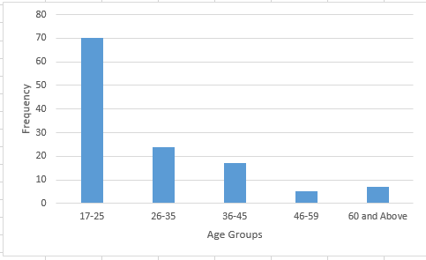

*Note*: The x-axis represents age groups (17-25, 26-35, 36-45, 46-59, 60 and above), and the y-axis represents the frequency of respondents. This figure presents the age distribution of a sample of 123 individuals. The majority of respondents (56.9%) are in the 17-25 age group, indicating a young sample population.

Table 2:

*The Gender Distribution of Sample Population (N=123)*

|  |  |  |
| --- | --- | --- |
| Age Group (years) | Frequency | Percentage (%) |
| Male | 77 | 62.6 |
| Female | 46 | 37.4 |
| Total | 123 | 100 |

*Note*: This table shows the gender distribution among the 123 respondents. Males constitute 62.6% of the sample, while females make up 37.4%. This indicates a male-dominant respondent pool.

Table 2 implies that there are more male respondents (62.6%) compared to female respondents (37.4%). This gender disparity might influence the overall perceptions of computer ethics, as different genders may have varying levels of exposure and experience with technology. Men might be more represented in technology-related fields, which could skew the data towards their experiences and viewpoints.

Figure 2:

***Gender Distribution of Respondents***

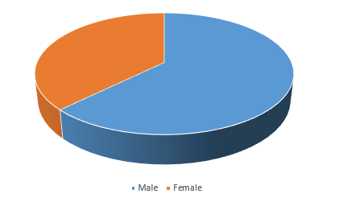

*Note*: This figure shows the gender distribution among 123 respondents. Males constitute 62.6% of the sample, while females make up 37.4%.

Table 3:

*Educational Background of the Sample Population (N=119)*

|  |  |  |
| --- | --- | --- |
| Educational Background | Frequency | Percentage (%) |
| High School | 36 | 30,3 |
| National Diploma | 5 | 4.2 |
| HND | 7 | 5.9 |
| Bachelor’s Degree | 41 | 34.5 |
| Master’s Degree | 15 | 12.6 |
| Doctorate Degree | 8 | 6.7 |
| Total | 119 | 100.00 |

*Note*: This table details the educational background of the 119 respondents. Most respondents have a Bachelor's Degree (34.5%), followed by those with a High School education (30.3%). Only 6.7% have a Doctorate Degree.

Table 3 indicates a well-educated sample, which could influence the awareness and understanding of computer ethics. A more educated population may have a higher capacity to grasp the complexities of ethical issues in technology. However, the presence of a significant portion with only high school education suggests that educational outreach on computer ethics should be accessible and understandable to those with varying levels of education. Tailoring educational programs to cater to different educational backgrounds can enhance the effectiveness of ethics education and ensure wider comprehension and application of ethical principles in technology use.

Figure 3:

*Educational Background of Respondents*

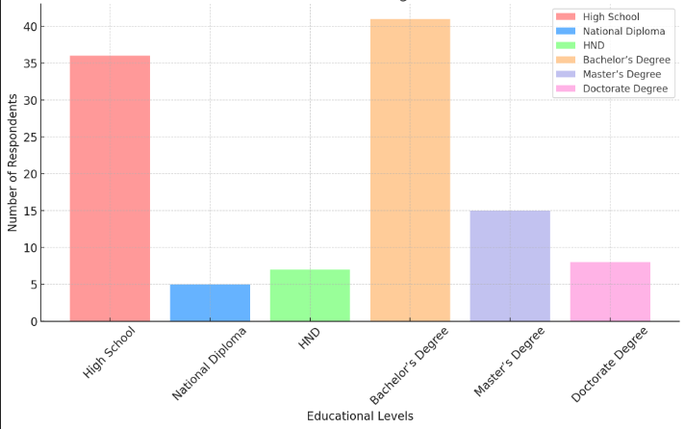

*Note*: This figure details the educational background of 119 respondents. Most respondents have a Bachelor's Degree (34.5%), followed by those with a High School education (30.3%).

Table 4:

*Professional Status of Sample Population*

|  |  |  |
| --- | --- | --- |
| Professional Status | Frequency | Percentage (%) |
| Student | 71 | 58.2 |
| Educator | 16 | 13.1 |
| I.T Professional | 16 | 13.1 |
| Others | 12 | 11.01 |
| Total | 122 | 100.00 |

*Note*: This table outlines the professional status of 122 respondents. A significant portion (58.2%) are students, with educators and IT professionals each making up 13.1% of the sample. Others constitute 11.01%.

Table 4 shows the majority of respondents are students (58.2%), followed by educators and I.T. professionals (13.1% each). This high number of students aligns with the younger age demographic and may reflect their educational environment's influence on their views about computer ethics. Students are often at the forefront of learning about new technologies and their ethical implications, making their perspectives valuable for understanding emerging trends in ethical thinking. The significant presence of educators and I.T. professionals suggests that these groups recognize the importance of ethical considerations in their fields.

Figure 4:

***Professional Status of Respondents***

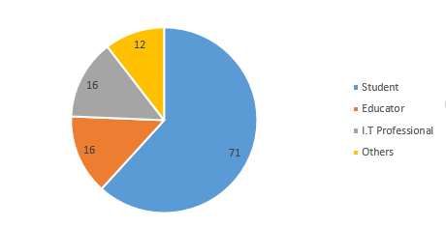

*Note*: This figure outlines the professional status of 122 respondents. A significant portion (58.2%) are students, with educators and IT professionals each making up 13.1% of the sample.

Table 5:

*How familiar are you with the concept of computer ethics?*

|  |  |  |
| --- | --- | --- |
| Familiarity Level | Frequency | Percentage (%) |
| Not Familiar | 8 | 6.5 |
| Slightly Familiar | 42 | 34.1 |
| Moderately Familiar | 35 | 28.5 |
| Very Familiar | 27 | 22.0 |
| Extremely Familiar | 11 | 8.9 |
| Total | 123 | 100.00 |

*Note*: This table illustrates respondents' familiarity with computer ethics. The largest group (34.1%) is slightly familiar, while 28.5% are moderately familiar. Only 6.5% are not familiar at all.

Table 5 shows that there is a need for increased education and awareness regarding computer ethics among the population. Educational programs and workshops could be beneficial in enhancing familiarity and understanding. The data indicates that while some respondents have a basic awareness of computer ethics, there is a substantial gap in deep, comprehensive knowledge.

Figure 5:

***Familiarity with Computer Ethics***

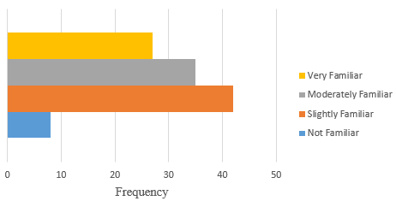

*Note*: This figure illustrates respondents' familiarity with computer ethics. The largest group (34.1%) is slightly familiar, while 28.5% are moderately familiar.

Table 6:

*As a computer professional, do you observe most of the ethical principles in your profession?*

|  |  |  |
| --- | --- | --- |
| Perception | Frequency | Percentage (%) |
| Strongly Disagree | 4 | 2.6 |
| Disagree | 18 | 14.4 |
| Neutral | 32 | 25.6 |
| Agree | 57 | 45.6 |
| Strongly Agree | 11 | 8.8 |
| Total | 123 | 100.00 |

*Note*: This table shows how respondents perceive their adherence to ethical principles in their profession. Most respondents agree (45.6%) that they observe these principles, while 25.6% are neutral. Only 2.6% strongly disagree.

Table 6 indicates a large proportion of respondents agree (45.6%) or strongly agree (8.8%) that they observe ethical principles in their profession. This indicates a generally positive attitude towards ethical practices among professionals. However, there is still room for improvement to ensure that more individuals adhere to ethical principles. The data suggests that while many professionals recognize and observe ethical principles, continuous education and reinforcement of these principles are essential to maintain high standards of ethical behavior.

Figure 6

***Observance of Ethical Principles***

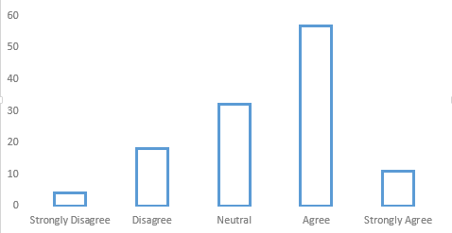

*Note:* The x-axis represents perception levels (Strongly Disagree, Disagree, Neutral, Agree, Strongly Agree), and the y-axis represents the frequency of respondents. This figure shows how respondents perceive their adherence to ethical principles in their profession. Most respondents agree (45.6%) that they observe these principles, while 25.6% are neutral.

Table 7:

*Can awareness of computer ethics minimize major computer/technology crimes in Nigeria?*

|  |  |  |
| --- | --- | --- |
| Perception | Frequency | Percentage (%) |
| Strongly Disagree | 6 | 4.9 |
| Disagree | 10 | 8.1 |
| Neutral | 27 | 22.0 |
| Agree | 63 | 51.2 |
| Strongly Agree | 17 | 13.8 |
| Total | 123 | 100.00 |

*Note*: This table examines if awareness of computer ethics can reduce technology-related crimes in Nigeria. The majority (51.2%) agree, indicating a belief in its positive impact. Only 4.9% strongly disagree.

Table 7 shows than more than half of the respondents (51.2%) agree that awareness of computer ethics can minimize major computer/technology crimes in Nigeria, showing a strong belief in the importance of ethical awareness in combating cybercrime. This highlights the potential impact of ethics education on reducing crime rates. The belief that ethical awareness can mitigate cybercrime underscores the need for comprehensive ethics training programs that not only educate but also empower individuals to act ethically

Figure 7:

***Impact of Computer Ethics Awareness on Crime***

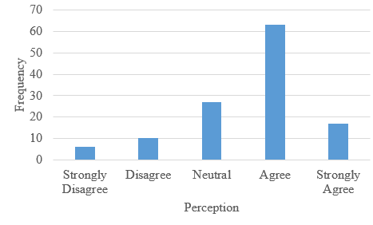

*Note:* The x-axis represents perception levels (Strongly Disagree, Disagree, Neutral, Agree, Strongly Agree), and the y-axis represents the frequency of respondents. This figure examines if awareness of computer ethics can reduce technology-related crimes in Nigeria. The majority (51.2%) agree, indicating a belief in its positive impact.

Table 8

*To what extent does computer ethics promote technological growth in Nigeria?*

|  |  |  |
| --- | --- | --- |
| Perception | Frequency | Percentage (%) |
| No extent | 7 | 5.6 |
| Little extent | 24 | 19.2 |
| Moderate extent | 33 | 26.4 |
| Great extent | 49 | 39.2 |
| Very great extent | 20 | 17.39 |
| Total | 115 | 100.00 |

*Note*: This table evaluates the extent to which computer ethics promote technological growth in Nigeria. A significant portion (39.2%) believes it has a great extent of influence, while 26.4% think it has a moderate extent.

Table 8 data shows that there is a strong link between ethical behavior and technological innovation. By adhering to ethical standards, individuals and organizations can foster trust, encourage collaboration, and create an environment conducive to innovation. Promoting ethical behavior in technology development can lead to more responsible and sustainable growth, benefiting both the industry and society at large.

Figure 8:

***Promotion of Technological Growth by Computer Ethics***

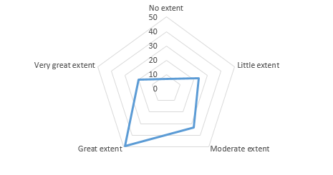

*Note*: This figure evaluates the extent to which computer ethics promote technological growth in Nigeria. A significant portion (39.2%) believes it has a great extent of influence.

Table 9:

*How important do you believe ethics is for the advancement of Technology?*

|  |  |  |
| --- | --- | --- |
| Perception | Frequency | Percentage (%) |
| Not Important | 3 | 2.4 |
| Slightly Important | 17 | 13.8 |
| Moderately Important | 29 | 23.6 |
| Very Important | 61 | 49.6 |
| Extremely Important | 13 | 10.6 |
| Total | 123 | 100.00 |

*Note*: This table reflects respondents' views on the importance of ethics in advancing technology. Most consider it very important (49.6%), with 23.6% viewing it as moderately important. Only 2.4% think it is not important.

Table 9 indicates that a majority (49.6%) believe ethics is very important, and an additional 10.6% believe it is extremely important for the advancement of technology, underscoring the critical role of ethics in technology development. This consensus emphasizes the necessity for ethical guidelines and frameworks in tech industries. The strong agreement on the importance of ethics highlights the need for clear ethical standards and regulations in the technology sector.

Figure 9:

***Importance of Ethics for Technology Advancement***

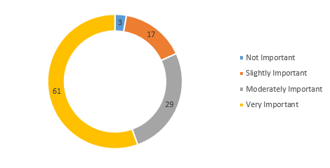

*Note*: This figure reflects respondents' views on the importance of ethics in advancing technology. Most consider it very important (49.6%), with 23.6% viewing it as moderately important.

Table 10:

*How concerned are you about your privacy when using Technology?*

|  |  |  |
| --- | --- | --- |
| Concern Level | Frequency | Percentage (%) |
| Not Concerned | 1 | 0.8 |
| Slightly Concerned | 24 | 19.5 |
| Moderately Concerned | 21 | 17.1 |
| Very Concerned | 33 | 26.8 |
| Extremely Concerned | 44 | 35.8 |
| Total | 123 | 100.00 |

*Note*: This table reveals how concerned respondents are about their privacy when using technology. A considerable number (35.8%) are extremely concerned, while 26.8% are very concerned. Only 0.8% are not concerned.

Table 10 indicates a high level of awareness and concern for privacy issues among the population. Privacy protection measures should be a priority in technology use and development. Privacy concern is a major ethical issue in computer which comprises of data protection, identity theft, and data sharing. The data reveals a strong demand for robust privacy protections, suggesting that users are increasingly aware of the risks associated with digital technologies.

Figure 10:

*Concern about Privacy When Using Technology*

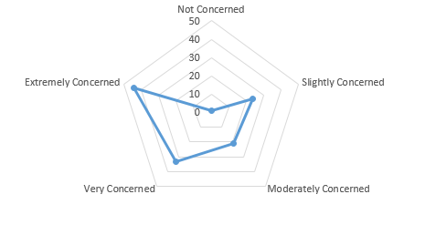

*Note:* This figure reveals how concerned respondents are about their privacy when using technology. A considerable number (35.8%) are extremely concerned, while 26.8% are very concerned.

Table 11:

*How often do you think about ethical implication when using the Internet?*

|  |  |  |
| --- | --- | --- |
| Level of Thinking | Frequency | Percentage |
| Never | 7 | 5.7 |
| Rarely | 29 | 23.6 |
| Sometimes | 35 | 28.5 |
| Often | 29 | 23.6 |
| Always | 23 | 18.7 |
| Total | 123 | 100.00 |

*Note*: This table shows how often respondents consider ethical implications when using the internet. The largest group (28.5%) sometimes think about it, and 23.6% often consider it. Only 5.7% never think about it.

Table 11is showing a moderate level of ethical consideration in their online activities. Increasing ethical awareness could lead to more responsible internet usage. The data indicates that while some individuals consider the ethical implications of their online actions, there is still a need for greater awareness and education

Figure 11:

*Thinking About Ethical Implications When Using the Internet*

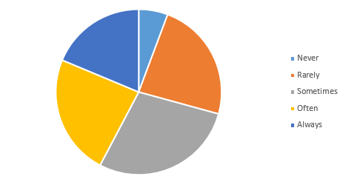

*Note:* This figure shows how often respondents consider ethical implications when using the internet. The largest group (28.5%) sometimes think about it, and 23.6% often consider it.

Table 12:

*Have you Ever Reported Unethical Behavior Online?*

|  |  |  |
| --- | --- | --- |
| Reporting Behavior | Frequency | Percentage (%) |
| Yes | 61 | 49.1 |
| No | 62 | 50.9 |
| Total | 123 | 100.00 |

*Note*: This table indicates whether respondents have reported unethical behavior online. Responses are almost evenly split, with 49.1% saying yes and 50.9% saying no. This shows a balanced perspective on reporting unethical behavior.

Table 12 indicates that the responses are almost evenly split, with 49.1% having reported unethical behavior online, suggesting that about half of the respondents are proactive in addressing unethical online activities. Encouraging more people to report unethical behavior could enhance the overall ethical standards online. The data highlights the importance of creating an environment where individuals feel empowered and supported to report unethical behavior.

Figure 12:

***Reporting Unethical Behavior Online***

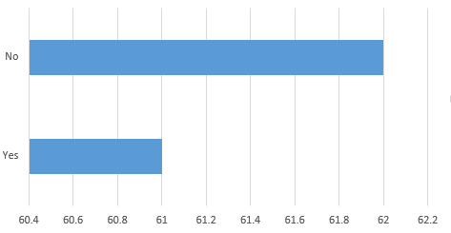

*Note:* The Y-axis represents reporting behavior (Yes, No), and the x-axis represents the frequency of respondents. This figure indicates whether respondents have reported unethical behavior online. Responses are almost evenly split, with 49.1% saying yes and 50.9% saying no.

Table 13:

Have you received any Formal Education or Training on Computer Ethics?

|  |  |  |
| --- | --- | --- |
| Training | Frequency | Percentage (%) |
| Yes | 58 | 47.2 |
| No | 65 | 52.8 |
| Total | 123 | 100.00 |

*Note*: This table shows whether respondents received formal education or training on computer ethics. A slight majority (52.8%) have not received such training, while 47.2% have.

Table 12 indicate slight majority (52.8%) have not received formal education or training on computer ethics, indicating a gap in formal ethical education that could be addressed to improve overall ethical awareness

Figure 13:

***Formal Education or Training on Computer Ethics***

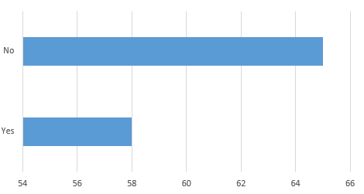

*Note*: The y-axis represents training status (Yes, No), and the x-axis represents the frequency of respondents. This figure shows whether respondents received formal education or training on computer ethics. A slight majority (52.8%) have not received such training, while 47.2% have.

Table 14:

*How effective do you think Current Educational Programs are in Teaching Computer Ethics?*

|  |  |  |
| --- | --- | --- |
| Effectiveness | Frequency | Percentage (%) |
| Very Ineffective | 17 | 13.8 |
| Ineffective | 27 | 22.0 |
| Neutral | 40 | 32.5 |
| Effective | 33 | 26.8 |
| Very Effective | 6 | 4.9 |
| Toatal | 123 | 100.00 |

*Note*: This table assesses the perceived effectiveness of current educational programs in teaching computer ethics. The majority view is neutral (32.5%), while 26.8% find them effective. Only 4.9% find them very effective.

Table 14 shows that opinions are mixed on the effectiveness of current educational programs, with the highest percentage (32.5%) being neutral. This suggests there is room for improvement in how computer ethics is taught. Feedback from participants can be used to enhance these programs. The data indicates that while some educational programs on computer ethics exist, their effectiveness varies.

Figure 14:

***Effectiveness of Educational Programs in Teaching Computer Ethics***

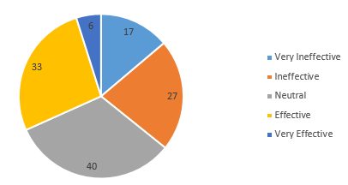

*Note*: This figure assesses the perceived effectiveness of current educational programs in teaching computer ethics. The majority view is neutral (32.5%), while 26.8% find them effective.

Table 155:

*Who do you think should be most responsible for ensuring ethical practices in technology?*

|  |  |  |
| --- | --- | --- |
| Stakeholders | Frequency | Percentage (%) |
| Individuals | 14 | 11.4 |
| Companies | 20 | 16.3 |
| Government | 47 | 38.2 |
| Educational Institutions | 36 | 29.3 |
| Religious Scholars | 5 | 4.1 |
| Total | 123 | 100.00 |

*Note*: This table identifies who respondents think should ensure ethical practices in technology. The majority (38.2%) believe it is the government's responsibility, followed by educational institutions (29.3%).

Table 17 shows that there is a strong expectation for government and educational institutions to take a leading role in promoting and enforcing ethical practices in technology. This highlights the need for clear policies, regulations, and educational programs that address ethical issues in technology.

Figure 155:

***Responsibility for Ensuring Ethical Practices in Technology***

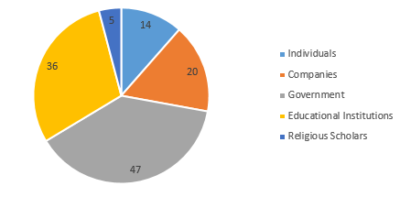

*Note*: This figure identifies who respondents think should ensure ethical practices in technology. The majority (38.2%) believe it is the government's responsibility, followed by educational institutions (29.3%).

Table 16:

*How often do you face Ethical Problems when using Technology in your Professional or Personal life?*

|  |  |  |
| --- | --- | --- |
| Perspective | Frequency | Percentage |
| Never | 15 | 12.2 |
| Rarely | 37 | 30.1 |
| Sometimes | 38 | 30.9 |
| Often | 23 | 18.7 |
| Always | 10 | 8.1 |
| Total | 123 | 100.00 |

*Note*: This table shows how often respondents face ethical issues when using technology. Responses vary, with 30.9% sometimes facing such problems and 30.1% rarely encountering them. Only 8.1% always face ethical problems.

Table 18 data indicates that ethical dilemmas are a common part of life for many individuals, highlighting the importance of providing support and resources to help them navigate these challenges. Organizations and institutions can offer training, counseling, and other resources to assist individuals in making ethical decisions

Figure 16:

***Frequency of Facing Ethical Problems When Using Technology***

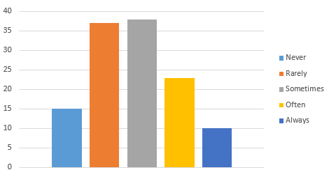

*Note*: The x-axis represents frequency levels (Never, Rarely, Sometimes, Often, Always), and the y-axis represents the frequency of respondents. This figure shows how often respondents face ethical issues when using technology. Responses vary, with 30.9% sometimes facing such problems and 30.1% rarely encountering them.

Table 17:

*What are the most common ethical issues you have encountered with computer applications?*

|  |  |  |
| --- | --- | --- |
| Ethical issues | Frequency | Percentage |
| Privacy cconcern | 38 | 31.1 |
| Computer Crimes | 33 | 27 |
| Accessibility Issues | 18 | 14.8 |
| Software Piracy | 18 | 14.8 |
| Hacking | 15 | 12.3 |
| Total | 112 | 100.00 |

*Note:* This table shows the most frequently reported ethical issues in computer applications. Privacy concerns are the most common issue (35.6%), followed by computer crimes (26%). Accessibility issues (11%), software piracy (13.7%), and hacking (13.7%) are also significant.

Figure 17:

*Common ethical issues you have encountered with computer applications.*

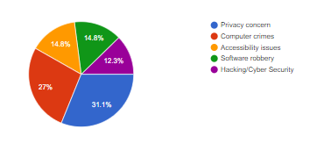

*Note:* This Figure summarizes how often respondents encounter ethical problems when using technology. The majority face such issues occasionally.

Table 18:

Unethical computer technology practices have a significant negative impact on various aspects of society, including privacy, security, trust in technology, and overall social well-being.

|  |  |  |
| --- | --- | --- |
| Ethical issues | Frequency | Percentage |
| Strongly disagree | 1 | 0.8 |
| Disagree | 9 | 7.4 |
| Neutral | 17 | 13.9 |
| Agree | 47 | 33.5 |
| Strongly agree | 48 | 39.3 |
| Total | 122 | 100.00 |

*Note:* Table 18 presents the distribution of respondent opinions regarding the impact of unethical computer technology practices on society. The data reveals a strong majority (74.2%) of respondents believe these practices have a significant negative influence on various societal aspects, including privacy, security, trust in technology, and overall well-being. This suggests a widespread concern about the ethical implications of computer technology.

Figure 18:

*Respondent Perceptions of Impact of Unethical Computer Technology Practices*

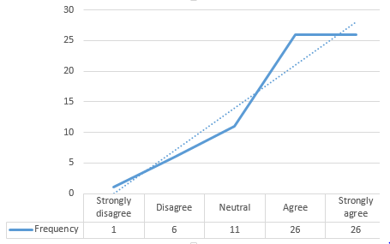

*Note:* The y-axis represents the frequency of respondents. This figure summarizes respondent views on the societal impact of unethical computer technology practices. A majority expresses concern about its negative effects. Which indicates that unethical practices has a great impact in the society.

## 

## 4.2 SUMMARY OF THE FINDINGS

Based on the analysis of data in Chapter Four, the following findings and suggestions emerged:

### 4.2.1 Role of Ethics in Computer Applications

* **Findings**: A significant portion of respondents (45.6% agree, 8.8% strongly agree) believe that adhering to ethical principles is crucial in their work with computers. The data also shows that a majority (51.2% agree, 13.8% strongly agree) think that awareness of computer ethics can help reduce computer-related crimes in Nigeria. This indicates a strong recognition of the role of ethics in promoting responsible and secure use of technology.

Furthermore, 49.6% of respondents believe that ethics is very important, and 10.6% believe it is extremely important for technological advancement. This suggests that ethical practices are not only seen as necessary for day-to-day operations but also as foundational for long-term growth and innovation in the technology sector.

* **Discussion**: These findings highlight a positive attitude towards ethics among computer professionals and students. The strong agreement on the importance of ethics shows that there is a widespread understanding of its role in ensuring the responsible use of technology. This awareness can contribute to creating a safer and more trustworthy technological environment, as ethical behavior helps prevent misuse and abuse of technology.
* **Suggestions**: To build on this understanding, it is recommended to integrate comprehensive ethics education into computer science curricula and professional development programs. Workshops, seminars, and continuous education initiatives can help reinforce the importance of ethical behavior. Institutions should also encourage discussions and case studies on ethical dilemmas to prepare students and professionals to handle such situations effectively.

### 4.2.2 Ethical Issues in Computer Technology Growth

* **Findings**: The main ethical issues identified include privacy concerns (35.6%), computer crimes (26%), software piracy (13.7%), and hacking (13.7%). Privacy concerns are the most significant, reflecting worries about data security and personal information protection. Computer crimes, including cyber-attacks and unauthorized access, are also major concerns, highlighting the need for robust cyber security measures.

Software piracy and hacking are also prevalent issues, indicating a need for better enforcement of intellectual property laws and stronger measures to prevent unauthorized access to systems and data. Additionally, 52.8% of respondents have not received formal education or training on computer ethics, which points to a significant gap in knowledge that could contribute to these ethical issues.

The data also indicates that 26.8% of respondents find current educational programs on computer ethics effective, while 32.5% remain neutral, suggesting that there is room for improvement in how ethics is taught and understood. Most respondents (38.2%) believe that the government should be responsible for ensuring ethical practices in technology, followed by educational institutions (29.3%).

* **Discussion**: These findings underscore the need for stronger ethical guidelines and policies to address the prevalent issues of privacy, security, and intellectual property. The lack of formal education on ethics highlights a critical area that needs attention. The belief that the government and educational institutions should take the lead in ensuring ethical practices points to the need for structured and institutional oversight.
* **Suggestions**: Develop and enforce robust policies and guidelines to address privacy, security, and piracy concerns. Educational institutions should offer specialized training programs focused on these issues, and governments should work on creating and enforcing regulations to protect data and intellectual property. Raising awareness about ethical responsibilities through educational campaigns can help mitigate these challenges. Additionally, improving the effectiveness of ethics education programs by incorporating practical examples and real-world scenarios can enhance understanding and application of ethical principles.

### 4.2.3 Impact of Unethical Computer Technology Practices on Society

* **Findings**: Unethical practices in computer technology have significant negative impacts on society. A large portion of respondents (37.1% agree, 37.1% strongly agree) believe that these practices harm societal well-being. This includes issues such as privacy violations, security breaches, and loss of trust in technology. The findings indicate that unethical behavior can lead to a wide range of problems, from personal data theft to large-scale cyber-attacks, affecting both individuals and organizations.

Additionally, 30.9% of respondents sometimes face ethical problems when using technology, and 30.1% rarely encounter them. This shows that ethical challenges are common, though not always frequent. Furthermore, the responses are nearly split on reporting unethical behavior online, with 49.1% having reported such behavior and 50.9% not having done so. This balance suggests that while many individuals are proactive in addressing unethical online activities, there is still a need to encourage more reporting to maintain high ethical standards.

* **Discussion**: These findings highlight the pervasive nature of ethical challenges in both professional and personal technology use. The significant negative impact of unethical practices on society emphasizes the need for continuous education, awareness programs, and strict enforcement of ethical standards. The split in reporting unethical behavior online indicates that while there is some proactive action, there is also a significant portion of the population that may be unaware of how to report or hesitant to do so.
* **Suggestions**: Implement continuous education and awareness programs to promote ethical behavior. Establish strict enforcement mechanisms for ethical standards and create platforms for reporting unethical practices. Institutions should engage in community outreach to educate the public on the importance of computer ethics. Encouraging a culture of reporting unethical behavior and providing clear guidelines on how to do so can help maintain high ethical standards.

## 4.3 Chapter Summary

Chapter four contains the study's findings and comments, which are based on data collected from Google Form. Although there is opportunity for more education and awareness, the respondents' acquaintance with computer ethics is outstanding. The majority of respondents agree that upholding moral standards in their line of work is crucial and think that raising people's knowledge of computer ethics can reduce the number of crimes in Nigeria involving technology. Furthermore, a large number of respondents believe that ethics are crucial to the advancement of technology and acknowledge its significance in promoting technical growth. The respondents' widespread privacy concerns underscore the necessity of effective privacy protection policies. Lastly, there is a need for development in these programs as opinions regarding how well-taught computer ethics are in present educational programs are divided.

# CHAPTER FIVE

**SUMMARY, CONCLUSION AND RECOMMENDATION**

## 5.0 Introduction

This chapter provides a comprehensive summary of the entire research on ethical issues in computer technology and its role as an instrument of technological growth. It also presents the conclusions drawn from the findings and offers recommendations for future research and practical applications. This chapter aims to consolidate the insights gained from the previous chapters and provide actionable suggestions for stakeholders to address the ethical challenges in computer technology.

## 5.1 Summary

The study investigated the ethical issues in computer technology as an instrument of technological growth. Over the years, the rapid advancement of computer technology has brought significant benefits, including increased access to information and communication, new business opportunities, and enhanced efficiency in various sectors. However, this growth also comes with increased risks to cyber security, privacy concerns, and ethical dilemmas.

Chapter one gave a summary of the research issue and focused on the moral conundrums that computer technology presents. The study's background, problem statement, research questions, aims, objectives, significance, scope, and limitations were all covered. Important ethical concerns included the over-reliance on intelligent machines, privacy, criminality, software piracy, and cybercrime.

Chapter Two reviewed related literature study included the background of ethical issues in computing history as well as the theoretical framework of computer ethics. In order to provide a basis for comprehending the present ethical issues in the industry, it reviewed earlier research and theories pertaining to computer ethics. The applicability of several ethical frameworks to computer technology was also covered.

Chapter Three detailed the research methodology, including the research design, data collection methods, and data analysis techniques. It described the steps taken to ensure the reliability and validity of the research findings, such as the selection of participants, the development of data collection instruments, and the procedures for data analysis.

Chapter Four presented the analysis of the collected data, discussing the findings in relation to the research questions. The data revealed significant concerns about privacy, cybercrime, software piracy, and the impact of unethical practices on society. The majority of respondents expressed worries about the invasion of privacy due to widespread data collection and surveillance practices. Many participants highlighted the prevalence of cybercrime, including hacking, identity theft, and online fraud, as a major ethical issue. The study found a high incidence of software piracy, with many users admitting to using pirated software due to high costs and lack of access to legal alternatives. Unethical practices in computer technology were found to have far-reaching effects, including financial losses, psychological stress, and diminished trust in digital systems. The analysis highlighted the need for enhanced ethical standards and practices in the field of computer technology

## 5.2 Conclusion

The study concluded that ethical issues in computer technology are multifaceted and pervasive, impacting various aspects of society. The rapid advancement of technology has outpaced the development of ethical guidelines and regulatory frameworks, leading to significant challenges in ensuring responsible and ethical use of computer technology. Key conclusions drawn from the study include:

* **Role of Ethics:** Ethics plays a crucial role in guiding the responsible use of computer technology. It helps in addressing issues related to privacy, security, and the equitable distribution of technological benefits.
* **Ethical Issues:** The primary ethical issues identified include privacy concerns, cybercrime, software piracy, and the over-reliance on intelligent machines. These issues pose significant risks to individuals and society, necessitating proactive measures to mitigate their impact.
* **Impact on Society:** Unethical practices in computer technology can lead to severe consequences, including data breaches, financial losses, and erosion of trust in digital systems. The study underscores the importance of fostering a culture of ethics within the technology community to ensure sustainable and equitable technological growth.

## 5.3 Recommendation

Based on the findings and conclusions of the research, the following recommendations are proposed:

* **Enhance Ethical Education:** Integrate comprehensive ethical education into computer science and technology curricula at all educational levels. This will equip future professionals with the knowledge and skills to navigate ethical dilemmas in their work.
* **Develop Regulatory Frameworks:** Governments and regulatory bodies should develop and enforce robust ethical guidelines and standards for the use of computer technology. This includes regulations to protect privacy, prevent cybercrime, and combat software piracy.
* **Promote Ethical Practices:** Organizations should foster a culture of ethics by promoting responsible data handling, ensuring privacy protection, and encouraging transparency in technological development. This can be achieved through regular training, ethical audits, and the establishment of ethical review boards.
* **Future Research:** Further research is needed to explore emerging ethical issues in new and evolving technologies, such as artificial intelligence and block- chain. Future studies should also investigate the effectiveness of existing ethical frameworks and propose new models to address the dynamic nature of technological advancements.
* **Community Engagement:** Engage the broader community, including users, developers, and policymakers, in discussions about ethical issues in computer technology. Public awareness campaigns and collaborative initiatives can help build a more ethically conscious society.

By implementing these recommendations, stakeholders can work together to address the ethical challenges posed by computer technology and ensure its positive impact on society.

Efforts should also be made to develop and refine tools and frameworks for assessing the ethical implications of new technologies. This includes creating mechanisms for ongoing monitoring and evaluation, as well as establishing platforms for dialogue and collaboration among stakeholders. By adopting a proactive and forward-looking approach, the field of computer ethics can continue to evolve and address the dynamic challenges of the digital age.

# REFRENCES

1. Byrne, J., & Marx, G. (2019). Technological innovations in crime prevention and policing. A review of the research on implementation and impact. *Journal of Police Studies, 20*(3), 17-40.

2. Deepak, K., Mago, B., & Taher, M. G. (2020). Information technology ethics and professional responsibilities. *International Journal of Advanced Science and Technology*. https://www.researchgate.net/publication/352159596

3. Freedman, L. (2019). *Computer: A history*. Oxford University Press.

4. Grosz, B. J., Grant, D. G., Vredenburgh, K., Behrends, J., Hu, L., & Simmons, A. (2019). Embedded ethics: Integrating ethics across CS education. *Communications of the ACM, 62*(8), 54-61. https://doi.org/10.1145/3330794

5. Kingston, J. (2020). *Japan's quiet transformation: Social change and civil society in the twenty-first century*. Psychology Press.

6. Kirsten, M., Katie, S., & Jeffery, S. (2019). Business and the ethical implications of technology: Introduction to the symposium. *Journal of Business Ethics, 160*(1), 307-317. https://doi.org/10.1007/s10551-019-04213-9

7. Kraemer, F., Van Overveld, K., & Peterson, M. (2019). Is there an ethics of algorithms? *Journal of Ethics and Information Technology, 13*(3), 251-260. https://doi.org/10.1007/s10676-010-9233-7

8. Lester, L. J. Y., & Dalat-Ward, Y. (2019). Teaching professionalism and ethics in information technology by deliberative dialogue. *Information Systems Education Journal, 17*(1), 1-4.

9. Li, F., Ruijs, N., & Lu, Y. (2023). Ethics and AI: A systematic review on ethical concerns and related strategies for designing with AI in healthcare. *Artificial Intelligence, 4*, 28-53. https://doi.org/10.3390/ai4010003

10. MacIntyre, J., Medsker, L., & Moriarty, R. (2020). Past the tipping point? AI and Ethics. *Springer, 2*, 65-10. https://www.researchgate.net/publication/369995486

11. Martin, K., Katie, S., & Jeffery, S. (2019). Ethical implementation of technology. *Journal of Business Ethics*. https://doi.org/10.1007/s10551-019-04213-9

12. Moore, G. C., & Benbasat, I. (2020). Development of an instrument to measure the perceptions of adopting an information technology innovation. *Information Systems Research, 2*(3), 192-222. https://doi.org/10.1287/isre.2.3.192

13. Onoja, E. O., Ibrahim, A. M., & Nasir, S. M. (2022). Ethical issues in computer as an instrument of technology growth. *Journal of Engineering and Computer Science, 4*(1), 08-14. https://doi.org/10.33545/26633582.2022.v4.i1a.58

14. Onoja, E. O., Suleiman, M. N., & Adegboye, Y. K. (2023). Ethical issues in computer as an instrument of technology growth. *Journal of Engineering and Computer Science, 5*(1), 08-14. https://dx.doi.org/10.33545/26648776.2023.v5.i1a.45

15. Rouse, M. (2020). Computer ethics. *Techopedia*. Retrieved from https://www.techopedia.com/definition/5499/computer-ethics

16. Sargolzaei, M. W., & Huang, C. (2021). Ethical issues associated with computer as an instrument to technological growth in China. *Journal of Information and Technology, 5*(1), 1-14. https://doi.org/10.53819/81018102t5028

17. Shivaji, P. M. (2022). What is ethics: Computing ethics? Retrieved from http://www.srtmun.ac.in/

18. Sukharev, O. S. (2022). Industrial growth and technological perspective. *Journal of New Economy, 23*(1). https://doi.org/10.29141/2658-5081-2022-23-1-1

19. Tadayoshi, K., Yasemin, A., & Wulf, L. (2023). Ethical frameworks and computer security trolley problems: Foundations for conversations. Retrieved from https://securityethics.cs.washington.edu

20. Woehler, L. L. (2020). Internet addiction and the relationship to self and interpersonal functioning within the alternative model for personality disorders (AMPD): Implications for psychosocial development.

## Appendix A

### Questionnaire

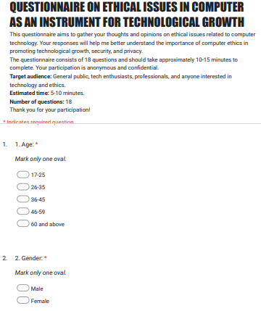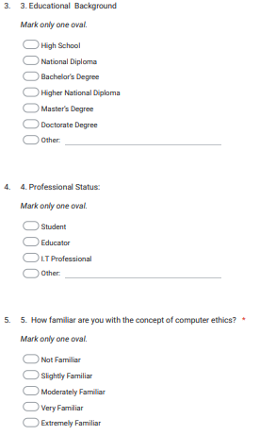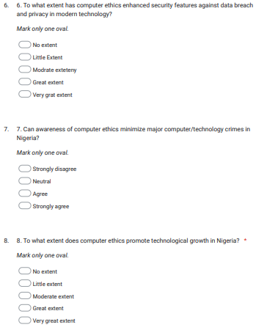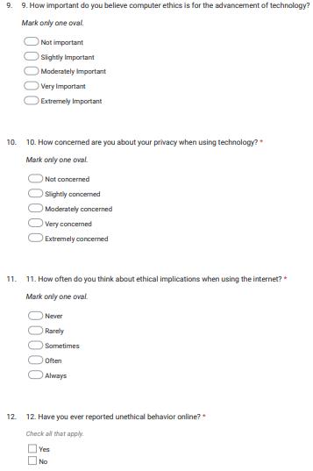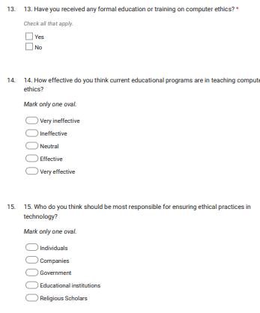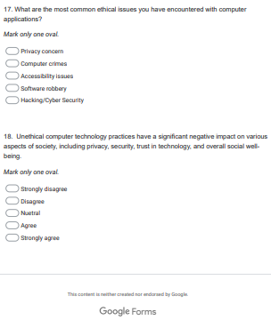

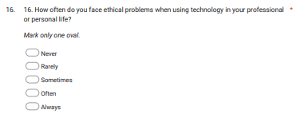

## Appendix B